**Assignment I**

**DATABASE DESIGN Z511**

**FNU ANIRUDH**

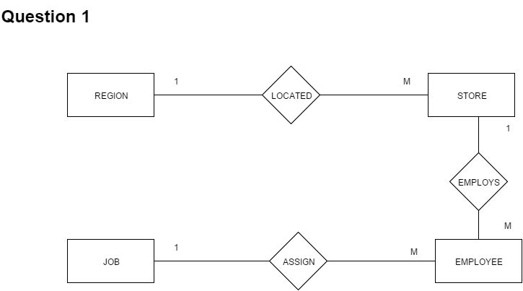

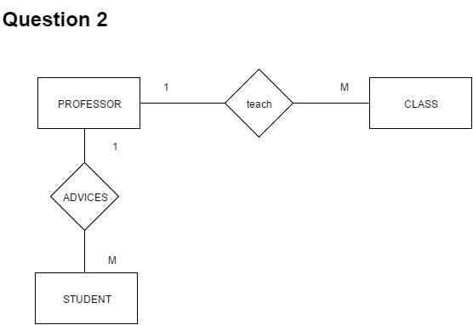

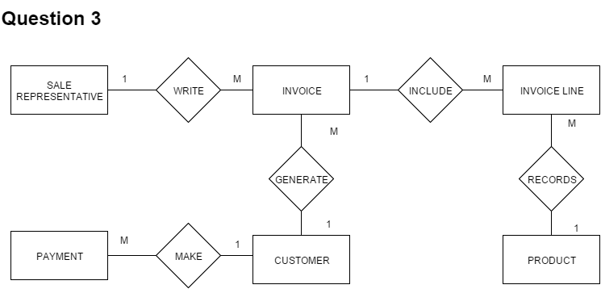

**Question 4**

**Entities: -** COURSE, CLASS, STUDENT

**Relationship: -** has, enrolls

**Connection: -** 1: M, M: N

**Business Rule:-**

1. Each course may have one or more classes, each class can have one and only one course.
2. One student can enroll in many classes, each class can enroll many students.

